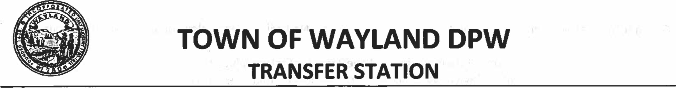
484 Boston Post Road 508-889-3037
Tuesday 8:OOAM - 4:OOPM Thursday 7:.OOAM - 4:OOPM Saturday 7:00AM - 4:OOPM

FY2023 PERMIT - $165.00

HOUSEHOLD TRASH
Must be disposed of in Orange Town Trash Bags ONLY
Bags of all sizes are available for purchase at grocery and hardware stores throughout Town as well as the Treasurer’s Office in the Town Building at 41 Cochituate Road, the
DPW Offices at 66 River Road, and the Transfer Station.

SINGLE-STREAM RECYCLING
Dispose of in the Blue Compactors ONLY
RECYCLE ONLY THESE THINGS
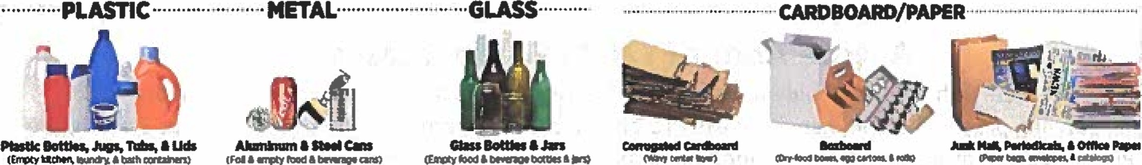
ALSO: 1 and 5 gal. buckets, milk crates, laundry baskets, garden trays/pots, kitty litter buckets, kiddie pools

TRASH THESE THINGS
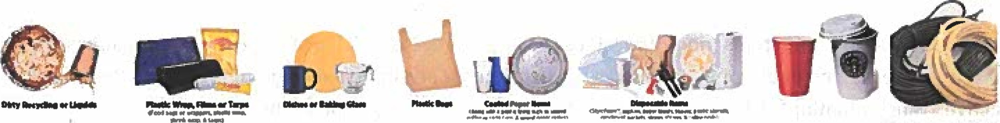

Wayland Organic Waste (WOW) Program
Composting at the Transfer Station is a convenient, environmentally beneficial, and cost-saving way to handle your organic waste.

*Clean and readable books may be placed in the Book Box. Book Box closes at 3:00PM
*Leaves and grass clippings may be disposed of in the yard waste area.
*Electronics disposal is the first Saturday of every month: $25 per item, $45+ per CRT/Projection TV
*Give and Take area is for items in good to excellent condition - No broken items, electronics, or wood furniture.
* No Business or Commercial Items No RENTAL TRUCKS or TRAILERS No Hazardous Materials (explosives, ammunition, and other dangerous or prohibited materials.
The Town of Wayland is pleased to provide trash and recycling disposal services at the Transfer Station. The Town offers “green” recycling of metal, styrofoam bubble material, electronics, oil, batteries, tires, mattresses & box springs, yard waste, give-n-take items and textile materials & composting. Additional services include paper-shredding events and rain-barrel & composting bin distribution. Town costs to dispose of bulky waste items (non-recyclables too large to fit in PAYT (Pay As You Throw) bags) has caused the Board of Public Works to institute a per-item and volume-based fee for such materials. Residents with an active Transfer Station sticker may pay these disposal fees at the Transfer Station at the time of disposal. These fees do not apply to single-stream recycling or household trash in PAYT bags. ________________________________________________________________________________________

Bulky Waste Fees* Paid at the Transfer Station at the time of disposal
Barrels / Bags larger than 33 gallons………………………………………………………………………. $20 per cubic yard
Cabinets $10 per item
Construction Debris……………………………………………………………………………………………………… $20 per cubic yard
Counter Tops $10 per item
Flooring / Tile $20 per cubic yard
Office Chairs……………………………………………………………………………………………….. $10 per item
Wood Pallets………………………………………………………………………………………………. $10 per item
Propane Tanks……………………………………………………………………………………………. $5 per item
Furniture (Wood furniture, chairs, etc.)…………………………………. $10 per item
Non-pullout Couches ……………………………………………………………………………………………. $20 per item
Mattresses/Boxsprings……………………………………………………………………………………… $50 per item
Misc Bulky Waste (items too large for PAYT bags)………………………………………………. $20 per cubic yard
Plastic Fencing $20 per cubic yard
Rugs & Carpet (5-foot length limit).. $10 per item
Sinks, Toilets, & Tubs $20 per item
Sleep Sofa / Pullout Couch $30 per item Tires (Car / motorcycle)………………………………………………………………………………………………. $ 5 per item
Tires (Large truck).. $10 per item
Windows ……………………………………………………………………………………………………………………… $10 per item
Wood Construction Debris (maximum 5’ in length)…………………………………………….. $20 per cubic yard
Minimum Fee……………………………………………………………………………………………………… $5
*Determination of Quantities of Materials and Applicable Fees are at the Sole Discretion of the Transfer Station Personnel

The DPW thanks you for your patronage and looks forward to continuing to provide this valuable service to Wayland residents.
https://www.wavland.ma.us/transfer-station-recvcling-center

