MEMA Hurricane Preparedness Week 2021
Messaging & Social Media Toolkit
HOW TO USE THIS TOOLKIT:
The Massachusetts Emergency Management Agency (MEMA) has developed this toolkit to help you share important hurricane preparedness messages in your community. The toolkit includes key messages, which can be tailored to write local press releases or blog posts, and sample social media posts and graphics that can be used or adapted for your community.
KEY MESSAGING POINTS:
Before a Hurricane
- Know Your Zone - Learn if you live in a hurricane evacuation zone.
- Find out whether your property is in a flood-prone or high-risk area by viewing the Federal Emergency Management Agency’s (FEMA) flood maps.
- Create and review your family emergency plan.
  - If you live or work in a flood zone, hurricane evacuation zone, or an area that is prone to flooding, you should be prepared to evacuate.
  - If you receive medical treatment or home health care services, work with your medical provider to determine how to maintain care and service if you are unable to leave your home or have to evacuate.
- Build an emergency kit for disasters that contains items that will sustain you & your family's specific needs if you are not able to leave your home.
- Prepare your home:
  - Elevating your furnace, water heater, and electric panel to higher floors if they may be at risk during a flood.
  - Ensure your smoke and carbon monoxide alarms are working and have fresh batteries.
  - If you live in a coastal community, review the Homeowner's Handbook to Prepare for Coastal Hazards.
- Coastal and inland flooding are significant hazards during a tropical storm or hurricane. Flood losses are not typically covered under renter and homeowner’s insurance policies. Consider purchasing flood insurance through the National Flood Insurance Plan (NFIP).
  - Flood insurance is available in most communities whether or not your building is in a flood-prone area, but there is a 30-day waiting period before it goes into effect.
When a Hurricane or Topical Storm Is Approaching
- Listen to local news stations and public officials for the latest information and updates.
- Follow instructions from public safety officials. If told to evacuate, do so immediately. If you must evacuate your home, take only essential items, including your emergency kit, and bring your pets.
- If you are not asked to evacuate and planning on riding out the storm at home, gather adequate supplies in case you lose power and water for several days and you are unable to leave.
- Prepare for power outages by charging cell phones and electronics and setting your refrigerator and freezer to their coldest settings. If you use electricity to get well water, fill your bathtub with water to use for flushing toilets.
- Prepare your home:
  - Secure or bring in outdoor objects (patio furniture, children's toys, trash cans, etc.) that could be swept away or damaged during strong winds or flooding.
  - If damaging winds are expected, cover all of your windows. If you don’t have storm shutters, board up windows with 5/8” exterior-grade or marine plywood.
  - Prepare for flooding by elevating items in your basement, checking your sump pump, unplugging sensitive electronic equipment, clearing nearby catch basins, and parking vehicles in areas not prone to flooding.
During a Hurricane
- Follow instructions from public safety officials. If told to evacuate, do so immediately. If you must evacuate your home, take only essential items, including your emergency kit, and bring your pets.
- Avoid driving or going outdoors during a storm. Flooding and damaging winds can make traveling dangerous.
- During strong winds in a hurricane, take shelter in a basement or an interior room (closet, interior hallway) on the lowest level of a building away from windows, doors, and outside walls.
- If you must evacuate or are traveling during flooding, remember:
  - Do not walk through flowing water. Most drownings occur during flash floods. Six inches of swiftly moving water can knock you off your feet.
  - Don’t drive through flooded roads - “Turn Around, Don’t Drown!” Cars can be swept away in only two feet of moving water. If your vehicle is trapped in rapidly moving water, stay in the vehicle. If the water is rising inside the vehicle, seek refuge on the roof.
  - Do not drive around road barriers. Roads and bridges may be washed out or structurally unsound.
- If you’re sheltering in place, listen to local news outlets for updates. Conditions may change quickly, so be prepared to evacuate if necessary.
After a Hurricane
- If you have evacuated, return home only when authorities say it is safe to do so. Check with local officials or call 2-1-1 to find shelter locations and other disaster information.
- Be a good neighbor. Check on family, friends, and neighbors, especially the elderly, those who live alone, those with medical conditions and those who may need additional assistance.
- Stay away from downed utility wires. Always assume a downed power line is live.
- If your power is out, follow these power outage safety tips.
  - Report power outages to your utility company.
  - Use generators and grills outside because their fumes contain carbon monoxide. Make sure your carbon monoxide detectors are working as it is a silent, odorless, killer. See more Generator Safety Tips.
- Don’t drive through flooded roads - “Turn Around, Don’t Drown!” Do not drive around road barriers. Roads and bridges may be washed out or structurally unsound.
- Check your home for damage:
  - If your home or property is damaged, take photos or videos to document your damage, and contact your insurance company.
- Clean and disinfect anything that got wet. Protect yourself during cleanup by wearing appropriate protective equipment such as gloves, safety glasses, and face masks.
SOCIAL MEDIA DETAILS:
TWITTER HANDLES TO FOLLOW | LINKS | HASHTAGS TO USE
@MassEMA  @NWSBoston  @NWSAlbany  @NHC_Atlantic  @femaregion1 | Hurricane Prep. Week Website:  https://www.mass.gov/hurricane-preparedness-week  Main Hurricane Safety Tips Website:  www.mass.gov/mema/hurricanes  Evacuation Zones:  https://www.mass.gov/info-details/hurricane-evacuation-zones  Friendly URL:  www.mass.gov/knowyourzone  Power Outage Safety Tips:  https://www.mass.gov/info-details/power-outage-safety-tips  Friendly URL:  www.mass.gov/mema/power-outages or bit.ly/Powers-Out | #HurricanePrep  #KnowYourZone

SOCIAL MEDIA POSTS:
SAMPLE POSTS
Know what #Hurricane terms mean:

Hurricane Watch = hurricane conditions (sustained winds >74 MPH) possible within 48 hours - be prepared!
Hurricane Warning = hurricane conditions expected within 36 hours - take action!
www.mass.gov/mema/hurricanes
Do you know the difference between #hurricane watches & warnings, #TropicalStorm watches & warnings and #StormSurge watches & warnings?

Learn the terms and how to prepare:
www.mass.gov/mema/hurricanes
Before a Hurricane
DYK #hurricanes can affect both coastal & inland areas in Massachusetts?

Learn more and how to prepare:
www.mass.gov/mema/hurricanes
#HurricanePrep
DYK: Hurricanes and tropical storms can bring storm surge, high winds, heavy rainfall, inland flooding & tornadoes and can impact all areas of Massachusetts?

Learn how to prepare yourself, your family, and your property: www.mass.gov/mema/hurricanes
#HurricanePrep
August and September are historically the peak of hurricane season in Massachusetts.
#HurricanePrep: www.mass.gov/mema/hurricanes
#KnowYourZone: www.mass.gov/knowyourzone
#Hurricanes & tropical storms can cause damage far away from the coast - W. Mass had significant damage from TS Irene with heavy rain/inland flooding and strong winds.

1) #KnowYourZone 2) Build A Kit 3) Make A Family Plan 4) Stay Informed
www.mass.gov/mema/hurricanes
DYK Hurricane Season continues through November 30th?

Take steps now to prepare which can also be used for other hazards throughout the year.

#HurricanePrep Steps 1) #KnowYourZone 2) Build A Kit 3) Make A Family Plan 4) Stay Informed: www.mass.gov/mema/hurricanes
Do you live, work, or vacation in a #hurricane #evacuation zone?
Find out with this interactive map: www.mass.gov/knowyourzone
#KnowYourZone #HurricanePrep
Learn if you live in a hurricane evacuation zone that may need to evacuate during a hurricane or tropical storm: www.mass.gov/knowyourzone
#HurricanePrep #KnowYourZone
If you live in an area that may #flood and may need an accessible transportation option to evacuate
• Plan with family, neighbors, friends to assist.
• Contact local public safety officials to make them aware of your needs.
https://www.mass.gov/info-details/emergency-preparedness-for-individuals-with-disabilities-and-access-and-functional
Prior to a #hurricane, create and review your family emergency plan.
• Have a plan to go to higher ground quickly if necessary.
• If you live or work in a flood zone, hurricane evacuation zone, or an area prone to flooding, be prepared to evacuate.
www.mass.gov/mema/hurricanes
Is your family ready for a #hurricane?
Create a family emergency plan so you’ll know what to do: bit.ly/Plan4Family #HurricanePrep
If you receive medical treatments or home health care services, work with your medical provider to determine how to maintain care and service if you are unable to leave your home during a hurricane or other emergency.
www.mass.gov/mema/hurricanes
#HurricanePrep
If your medical equipment uses electricity, talk to health care providers, utility company & your personal support network for how to use them and options during a power outage.
bit.ly/Powers-Out
#HurricanePrep
Emergency kits should include essential items that will help sustain you & your family for 3+ days.
See our checklist of items to include and customize for the needs of your family: bit.ly/Your-Kit
#ReadyMA #HurricanePrep
Doing renovations? Tips for properties in areas that may flood during a #hurricane:
• Elevate a furnace, water heater, & electric panel to higher floors
• Install a sump pump
• Install check valves in sewer lines to prevent floodwater from backing up
www.mass.gov/mema/hurricanes
Make sure your home has working Carbon Monoxide (CO) & smoke detectors with fresh batteries:
www.mass.gov/mema/hurricanes
#HurricanePrep
Don't Be Left in the Dark!
#Hurricanes often cause #PowerOutages.
Find out how to prepare: bit.ly/Powers-Out

#HurricanePrep #ReadyMA
The Massachusetts Homeowner's Handbook to Prepare for Coastal Hazards has been updated -
It's full of vital information on how residents can prepare for #hurricanes, #noreasters & #floods & measures to take in advance!
https://www.mass.gov/doc/homeowners-handbook-to-prepare-for-coastal-hazards/download
#HurricanePrep
Whether you are inside or outside of a flood prone area & whether you are a homeowner, renter, or business owner, you can purchase a flood insurance policy from the National Flood Insurance Program.

Call your insurance agent to get info
https://www.mass.gov/guides/floodplain-management
#HurricanePrep
Most homeowners’ and renters’ insurance does not cover flood damage.
Learn more about flood insurance at http://FloodSmart.gov
#HurricanePrep

When a Hurricane or Topical Storm Is Approaching
Listen to local news stations and public officials for the latest information and updates.
www.mass.gov/mema/hurricanes
#HurricanePrep
Follow instructions from public safety officials. If told to evacuate, do so immediately. If you must evacuate your home, take only essential items, including your emergency kit, and bring your pets.
www.mass.gov/mema/hurricanes
#HurricanePrep
• Prepare for power outages by charging cell phones and electronics and setting your refrigerator and freezer to their coldest settings.
• If you use electricity to get well water, fill your bathtub with water to use for flushing toilets.
bit.ly/Powers-Out
#HurricanePrep
Tie down or bring in outdoor objects (patio furniture, children’s toys, trash cans, etc.) that could be swept away or damaged during strong winds or flooding.
www.mass.gov/mema/hurricanes
#HurricanePrep
Unplug sensitive electronic equipment before flooding occurs.
Do not touch electrical equipment if you are wet or standing in water.
www.mass.gov/mema/hurricanes
#HurricanePrep
Before a #flood:
• Elevate items stored in the basement and other low-lying flood prone areas to minimize damage from flooding.
• If you have a sump pump, check that it is functioning properly.
www.mass.gov/mema/hurricanes
#HurricanePrep
Before a #flood:
Clear street catch basins and storm drains to prevent or reduce street flooding.
www.mass.gov/mema/hurricanes
#HurricanePrep

During a Hurricane
Follow instructions from public safety officials. If told to evacuate, do so immediately. If you must evacuate your home, take only essential items, including your emergency kit, and bring your pets.
www.mass.gov/mema/hurricanes
Avoid driving or going outdoors during a storm. Flooding and damaging winds can make traveling dangerous.
www.mass.gov/mema/hurricanes
During strong winds in a hurricane, take shelter in a basement or an interior room (closet, interior hallway) on the lowest level of a building away from windows, doors, and outside walls.
www.mass.gov/mema/hurricanes
Do not drive or walk into water. It only takes 6 inches of swiftly moving water to knock you off your feet!
www.mass.gov/mema/hurricanes
Turn around, don’t drown!
• Never drive into a flooded roadway. Cars can be swept away in 2 ft. of moving water.
• Do not drive around road barriers. Roads and bridges may be washed out or structurally unsound.
www.mass.gov/mema/hurricanes
If you’re sheltering in place, listen to local news outlets for updates. Conditions may change quickly, so be prepared to evacuate if necessary.
www.mass.gov/mema/hurricanes

After a Hurricane
If you have evacuated, return home only when authorities say it is safe to do so.
Check with local officials or call 2-1-1 to find shelter locations and other disaster information.
www.mass.gov/mema/hurricanes
Be a good neighbor. Check on family, friends, and neighbors, especially the elderly, those who live alone, those with medical conditions and those who may need additional assistance.
www.mass.gov/mema/hurricanes
Power Outage Safety Tips:
• Avoid downed power lines & assume they are live
• Call 9-1-1 to report downed lines
• Call your utility company to report power outages.
• Keep #generators outside & away from building
Power outage safety tips: bit.ly/Powers-Out
Using a generator because the power is out?

• Keep generators outside and away from house. Carbon monoxide can kill. Make sure CO detectors are working.
• Follow manufacturer’s guidelines when using a generator.
• Generator safety tips: http://bit.ly/2H1nTBn
Turn around, don’t drown!
• Never drive into a flooded roadway. Cars can be swept away in 2 ft. of moving water.
• Do not drive around road barriers. Roads and bridges may be washed out or structurally unsound.
www.mass.gov/mema/hurricanes
Flooded homes can be dangerous
• Stay away from electrical utility equipment after a storm or if it is wet to prevent being electrocuted.
• Get a professional to check for loose wires, mold and hidden damage before re-entering.
www.mass.gov/mema/hurricanes
If your home or property experienced #flood damage, take photos or videos to document the damage and contact your insurance company.
Learn more about how to recover after a disaster: http://bit.ly/2CvEECF
Clean and disinfect anything that got wet. Protect yourself during cleanup by wearing appropriate protective equipment such as gloves, safety glasses, and face masks.
www.mass.gov/mema/hurricanes

Social Images:
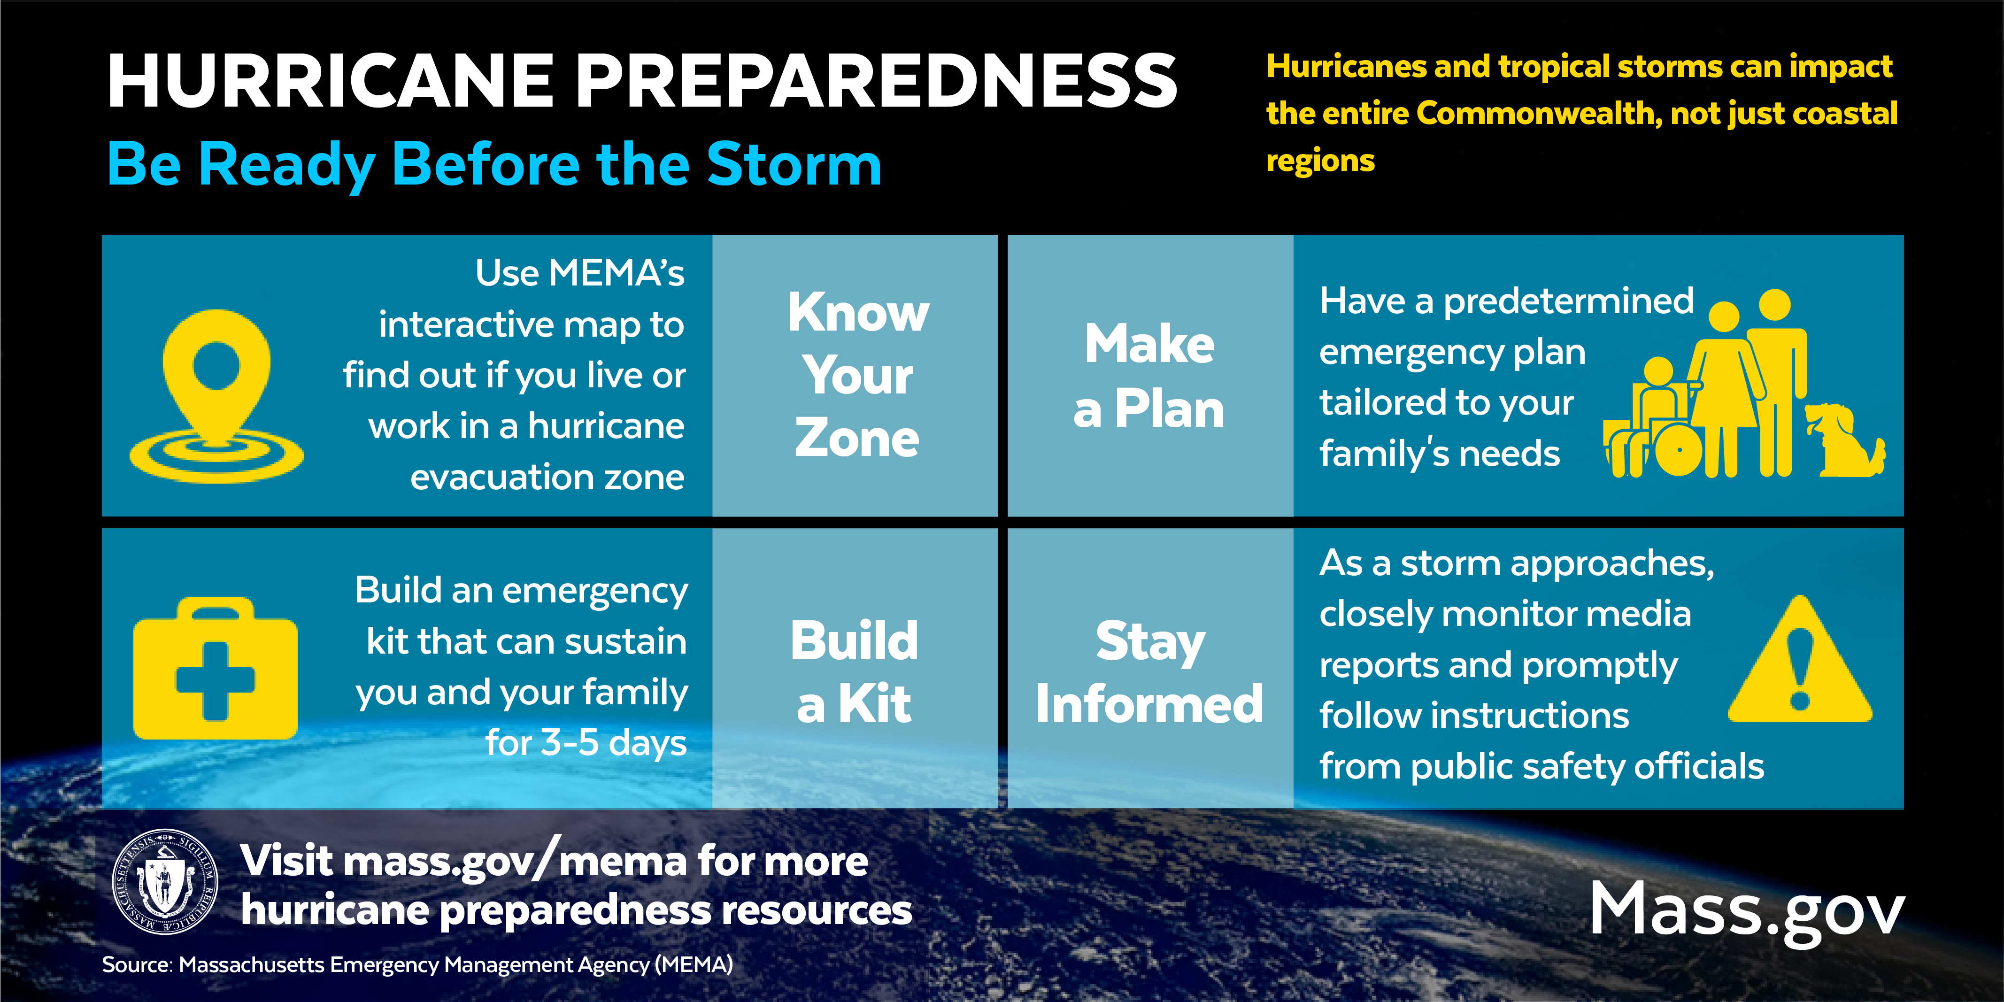 |  | 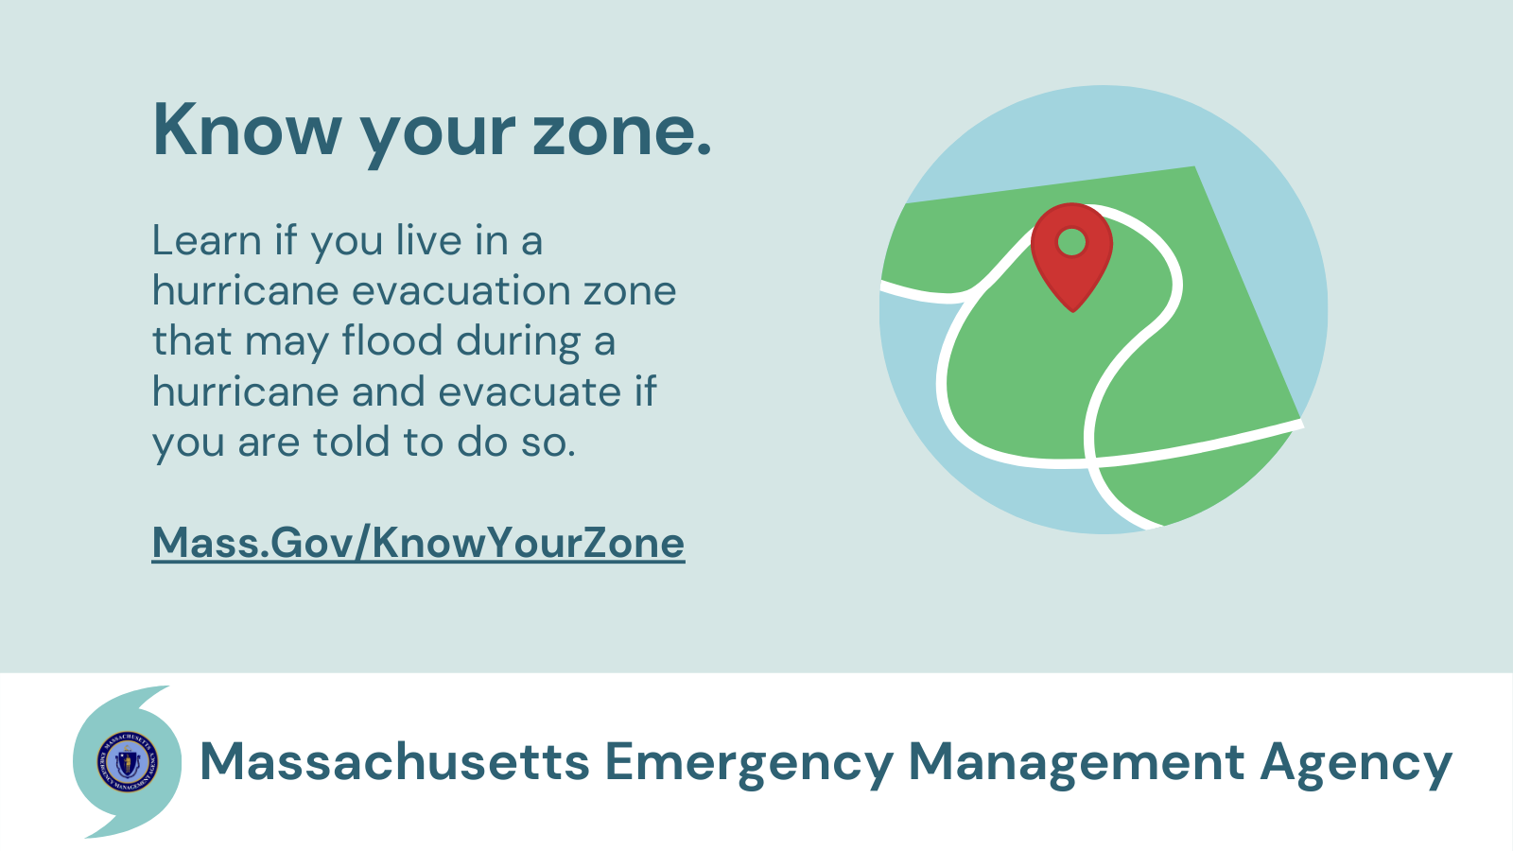
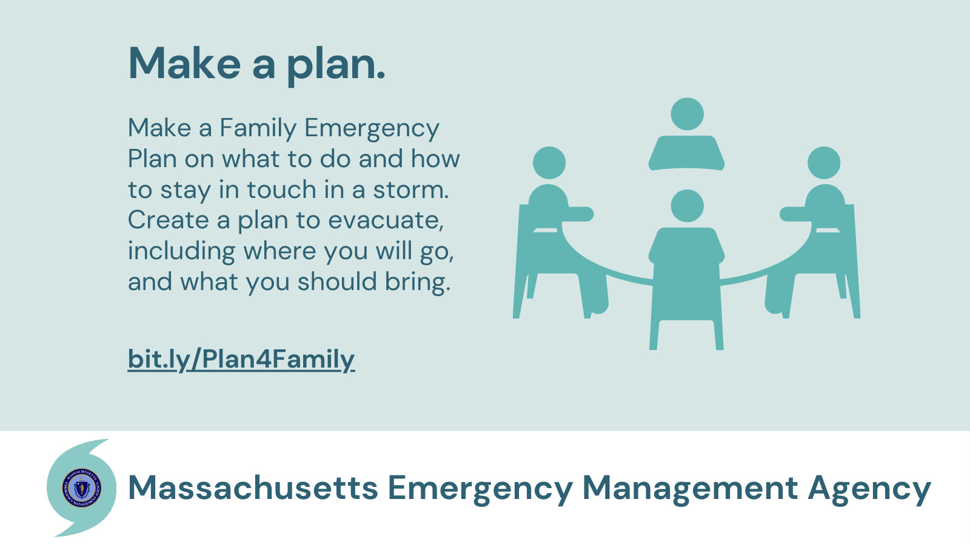 |  | 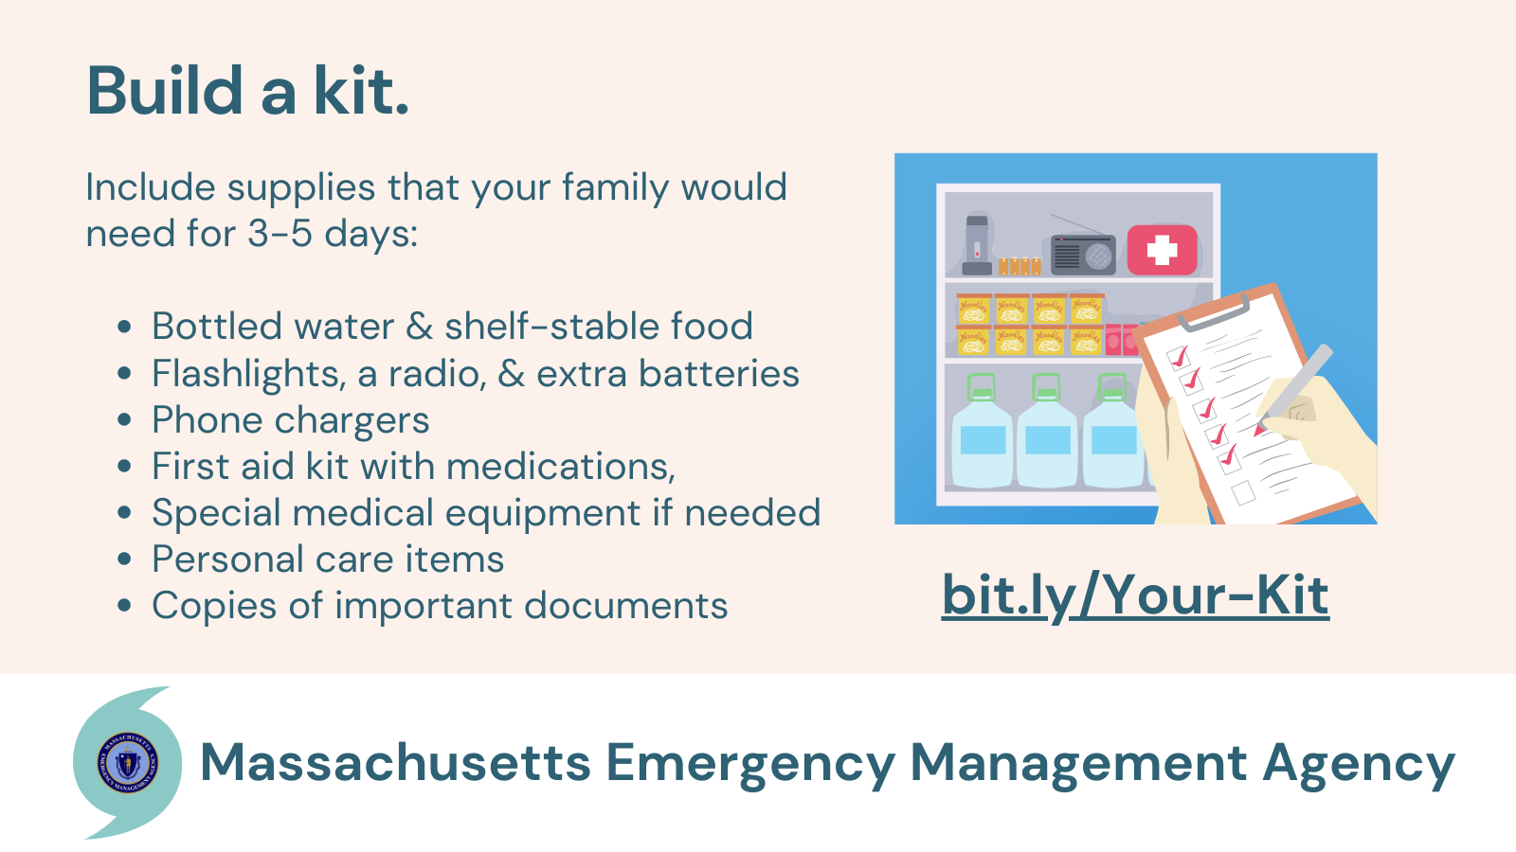
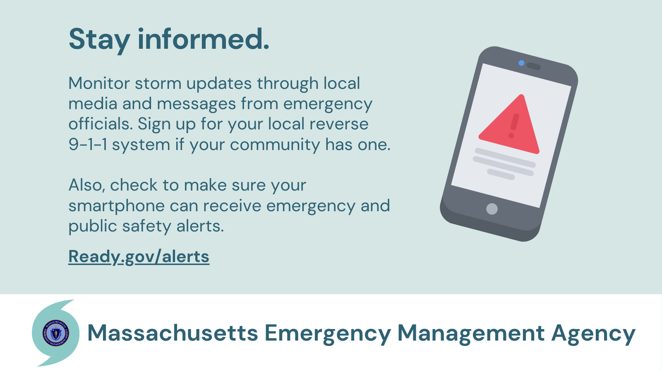 |  | 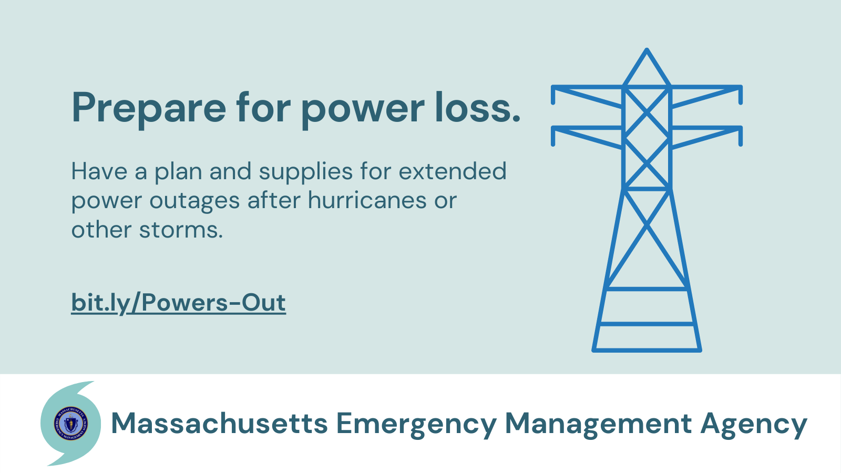
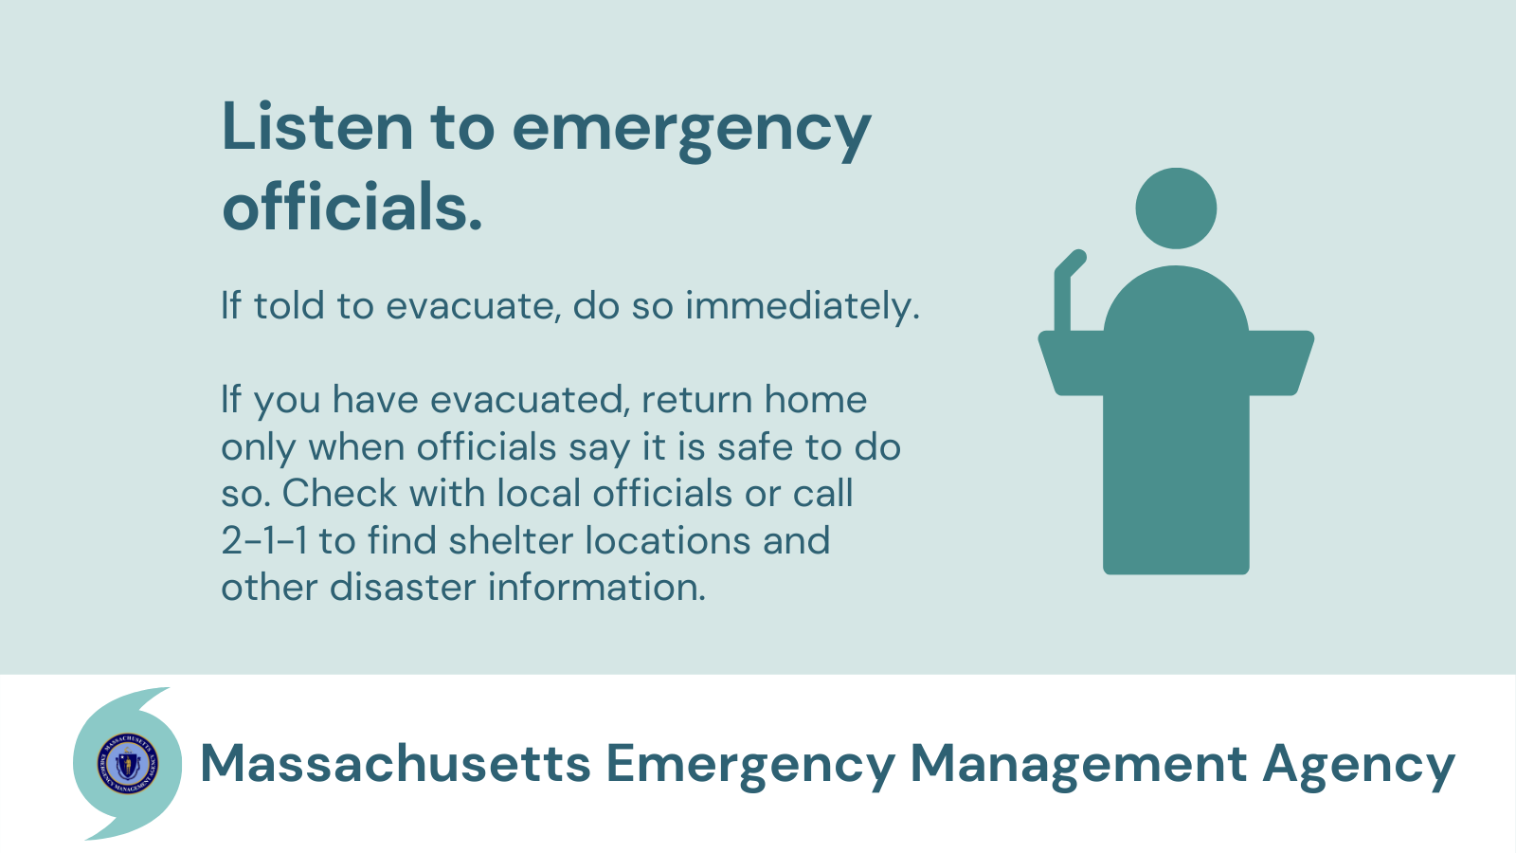 |  | 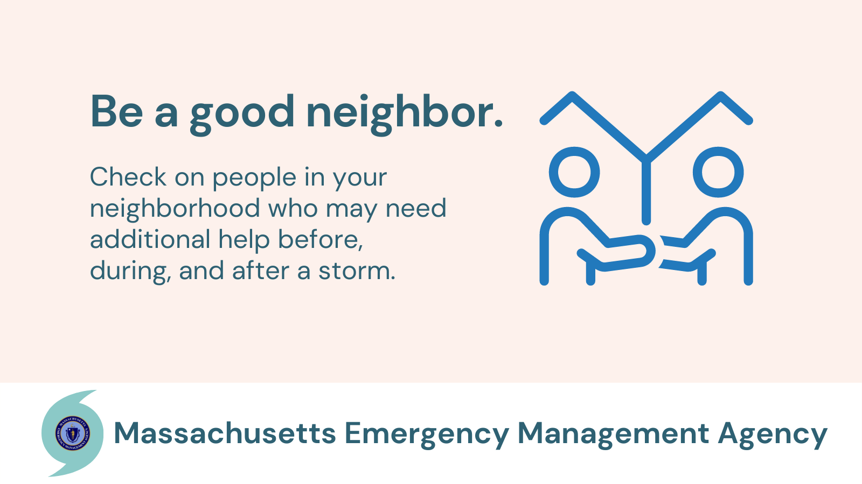
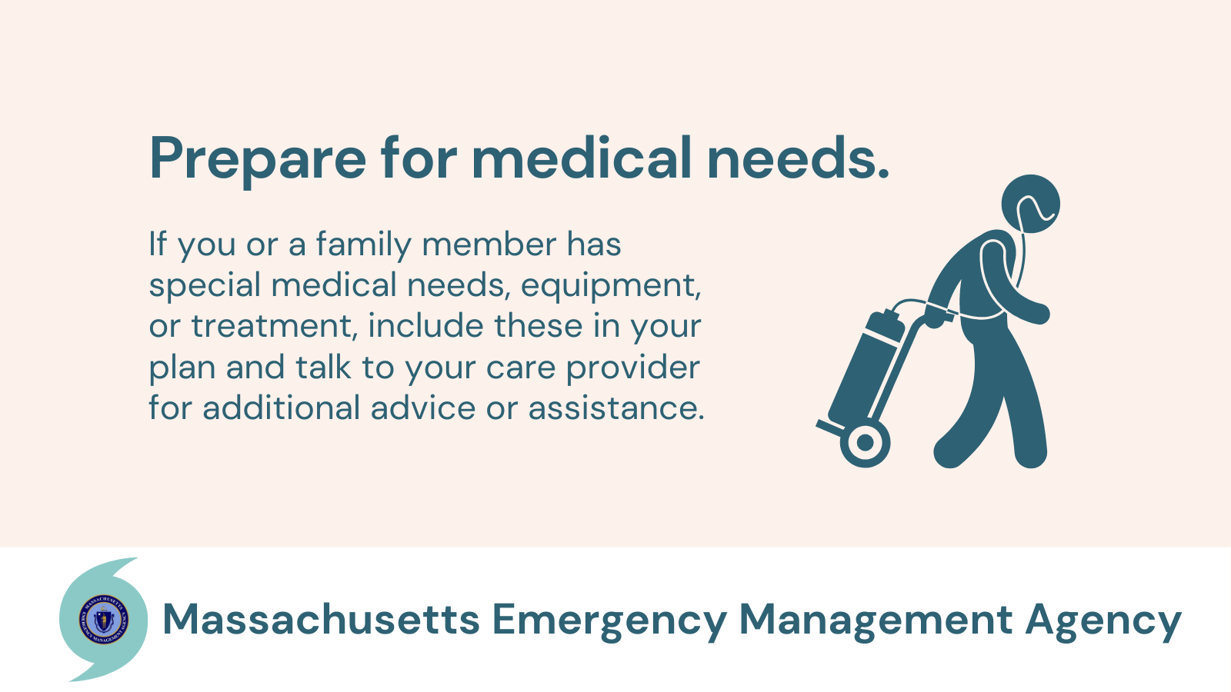 |  | 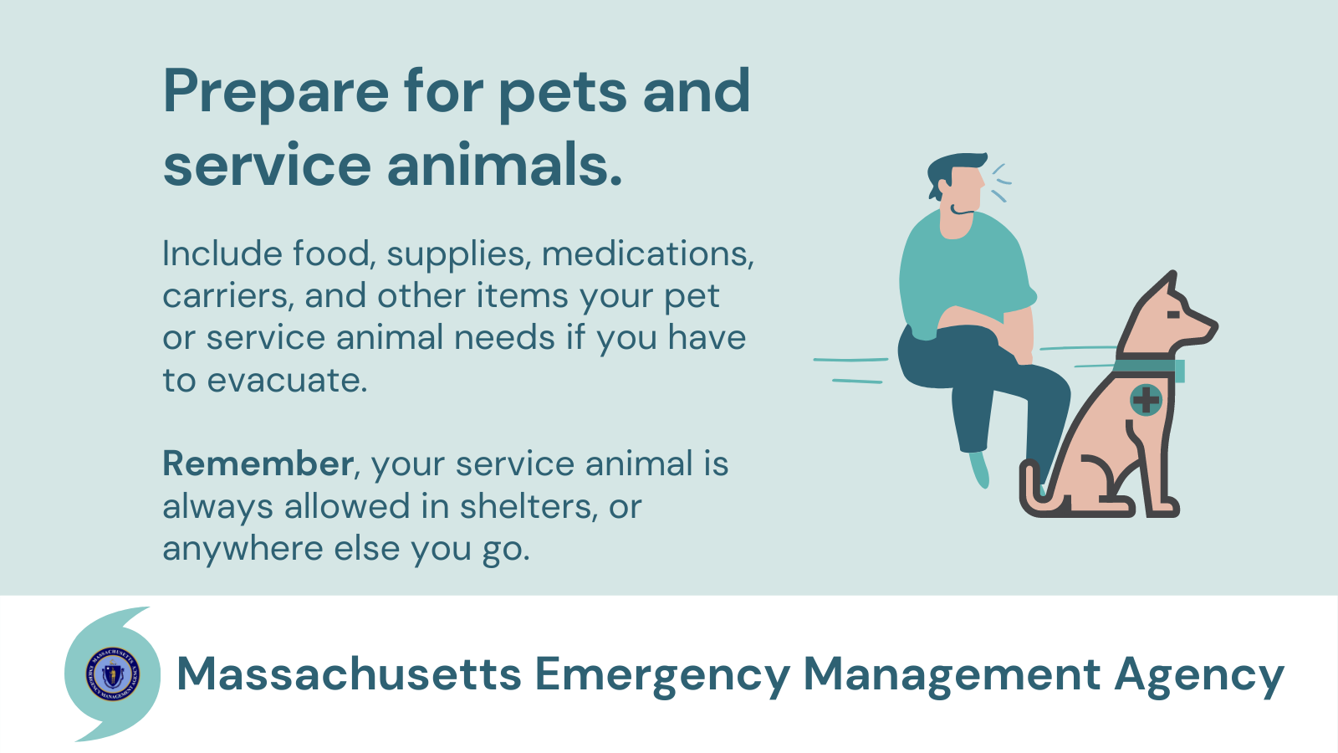
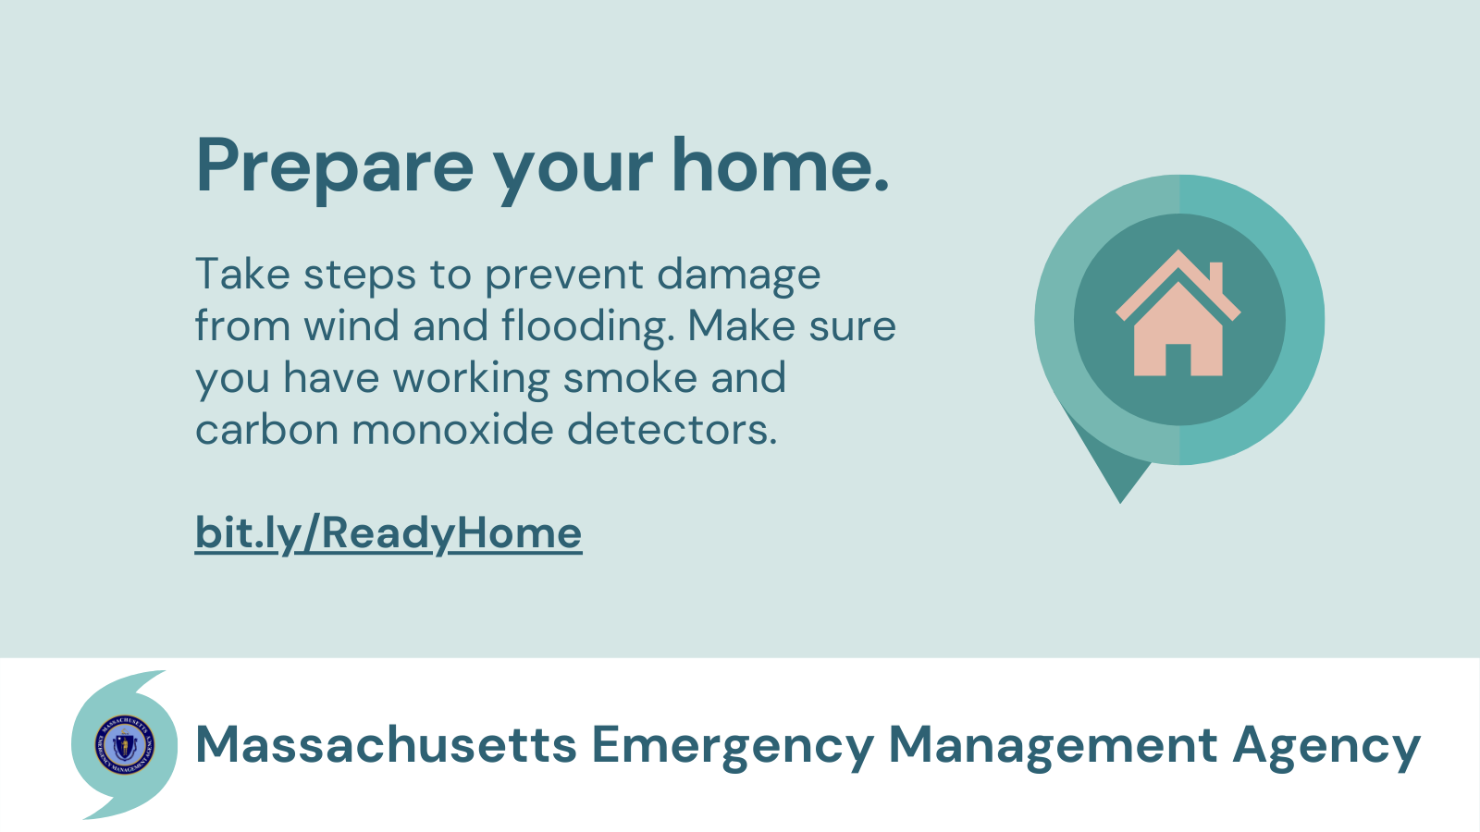 |  | 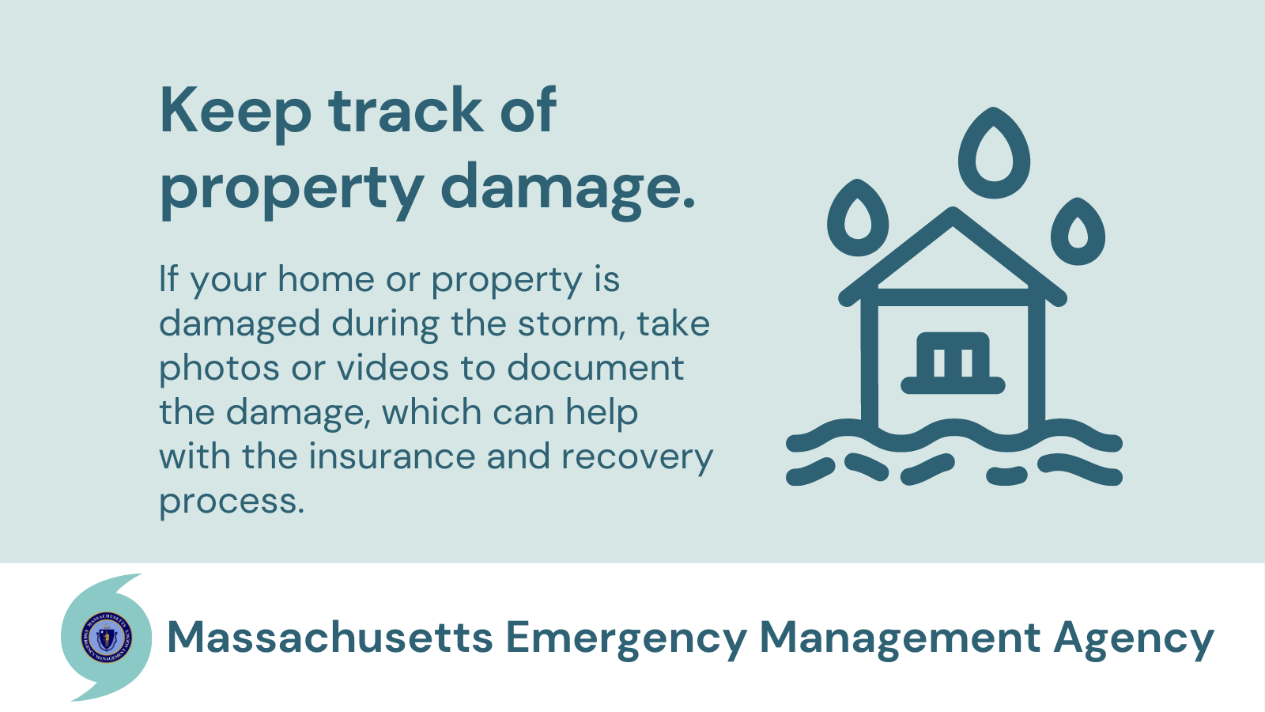
In addition to these graphics above, MEMA has created a Hurricane Graphics Library with graphics from the Massachusetts Emergency Management Agency (MEMA), the Federal Emergency Management Agency (FEMA), the National Weather Service (NWS) that can be used on social media and other platforms to promote hurricane preparedness.

